PRACTICAL DBMS
NAME: SIDDHI SRIVASTAVA. P
REG.NO:192521454
COURSE CODE: CSA0503
COURSE NAME: DATABASE MANAGEMENT SYSTEMS

Ex:No: 12 Simple Programming using REPEAT, WHILE
Aim:
To learn how to use various MySQL loop statements including while, repeat to run a block of code repeatedly based on a condition.
WHILE loop Syntax:
WHILE expression
DOstatements
END WHILE;
Procedure:
1. The WHILE loop checks the expression at the beginning of each iteration.
2. If the expression valuates to TRUE, MySQL will execute statements between WHILE and END WHILE until
the expression evaluates to FALSE.
3. The WHILE loop is called pretest loop because it checks the expression before the statements execute.
The following flowchart illustrates the WHILE loop
The following flowchart illustrates the WHILE loop statement:
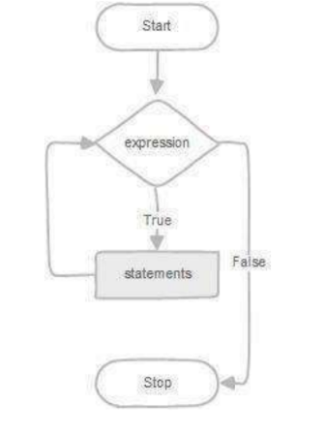
REPEAT loop Syntax:
REPEAT statements
UNTIL expression
END REPEAT;
Procedure:
1. First, MySQL executes the statements, and then it evaluates the expression.
2. If the expression evaluates to FALSE, MySQL executes the statements repeatedly until the expression
evaluates to TRUE.
3. Because the REPEAT loop statement checks the expression after the execution of statements, the REPEAT
loop statement is also known as the post-test loop.
The following flowchart illustrates the REPEAT loop statement:
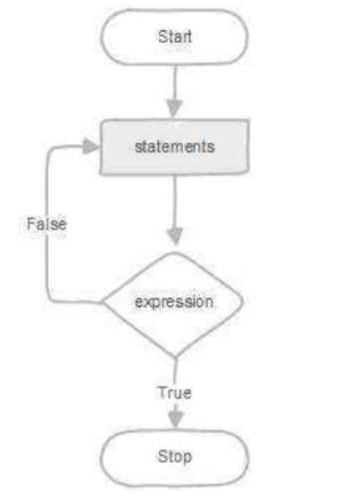
Program-1:
Write a function that uses WHILE statement to build a string repeatedly until the value of the variable becomes x greater than 5. Then, we display the final string using a SELECT statement.
Program-2:
Write a function that uses REPEAT statement which would repeat the loop until income is greater than or equal to 4000, at which point the REPEAT loop would be terminated.

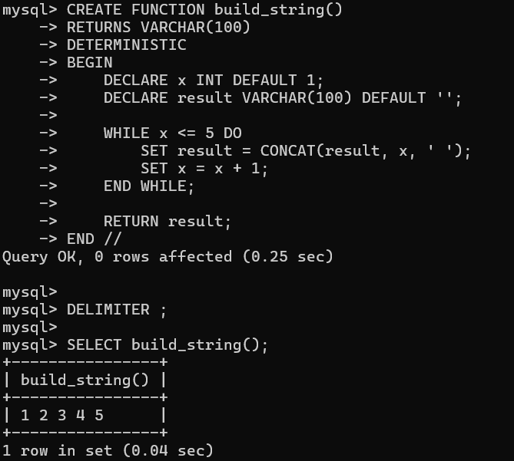
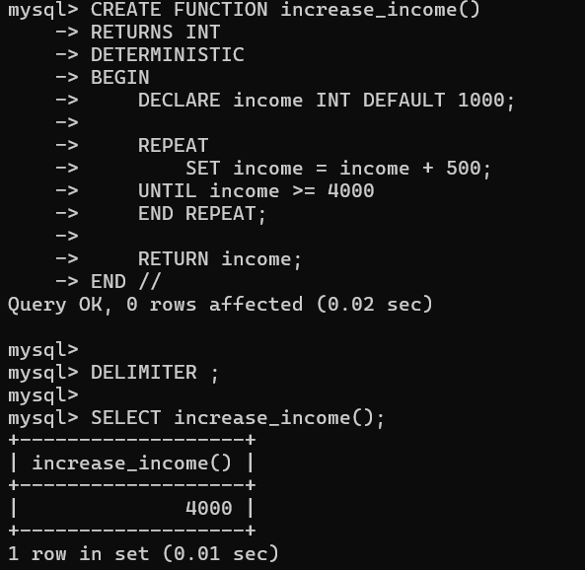
RESULT:
The records from the tables are displayed using auto_incrementsequence on the given relation.

